Student Research Project on Statistics courses:
http://goo.gl/UeoRrU

1. Basic Variable Types

Definitions

Data are the result of taking measurements or making observations on variables.

Categorical Variables. Values that consist of non-numerical information -- the data values consist of classes, categories, or presence/absence of a characteristic.

Numerical or Quantitative Variables. Values constitute numerical information --the data values are numbers. Numerical variables can be further classified as:

Discrete Variable. If the possible data values of numerical data are isolated points, i.e., there are gaps between the possible values, the data is discrete. (example: counts; rate on a scale of 1 to 10)

Continuous Variable. If the possible data values of numerical data consist of all numbers within an interval, i.e., there are no gaps between the possible values, the data is continuous (example: diameter of a pipe)

2. Levels of Measurement

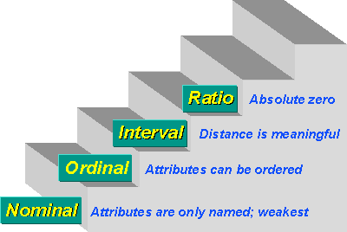

- Nominal level measurement. Merely classifies units into non-ordered categories.

Example: Male/Female, eye color, car model
Nominal means 'name'
Categories are exclusive and exhaustive

- Ordinal level measurement. Classifies units into ranks or ordered categories.

Ranks: 1st, 2nd, 3rd... place finishers in race
Ordered categories: {none = 0, low=1, medium=2, high=3}

- Interval level measurement. Differences are meaningful; (example: temperature °F).

A fixed difference anywhere on the measurement scale always corresponds to the same difference on the trait being measured:

Example: a one degree temperature (°F) difference always means the same thing. The difference between 60°F and 61°F is the same as between 100°F and 101°F.

Interval-level measurement (ctd.)

General rule:

x = true trait being measured (e.g., actual temperature)
y = observed measurement (measured temperature)

Interval-level measurement means that:

If |x_{i} - x_{j}| = |x_{k} - x_{l}| then |y_{i} - y_{j}| = |y_{k} - y_{l}|

for all i, j, k, l

A plot of y vs. x is a straight line

- Ratio level measurement. Both differences and ratios are meaningful;

Example: temperature °Kelvin
Ratio of 4 to 2 lbs means same as 400 to 200 lbs (twice as heavy)
Like interval-level, but has a "0" point

Comment: Nominal and ordinal data can be coded into numbers, usually for computer analysis. This does not make the data quantitative -- arithmetic cannot be performed on these numbers.

Possible Combinations of Variable Type and Level of Measurement

Level of Measurement | Variable Type
Level of Measurement | Discrete | Continuous
Nominal | Y
Ordinal | Y
Interval | Y | Y
Ratio | Y | Y

Some Special Cases

How much do you agree with this statement: "The President of the US is doing a good job?"

1. Disagree a lot
2. Disagree somewhat
3. Neither agree nor disagree
4. Agree somewhat
5. Agree a lot

Only ordinal measurement (ordered response categories)

Visual Analog Scales

Likert-type item
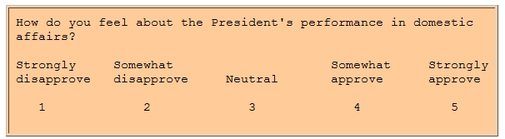

Discrete Visual Analog Scales
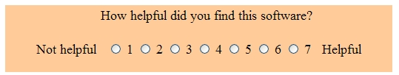

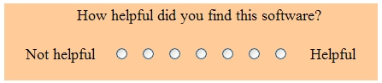

Other Visual Analog Scale Examples

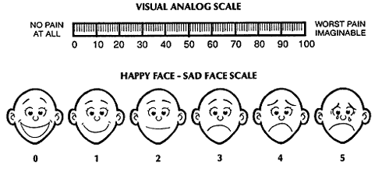

3. Quality Control
William E. Deming (Father of Quality Control)

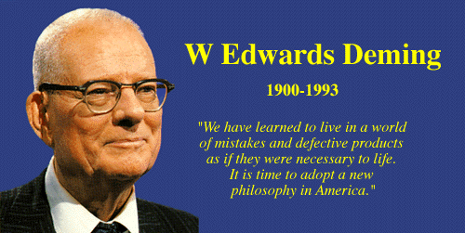

- Ignored in America
- Partly responsible for Japan's technological revolution
- Total Quality Management

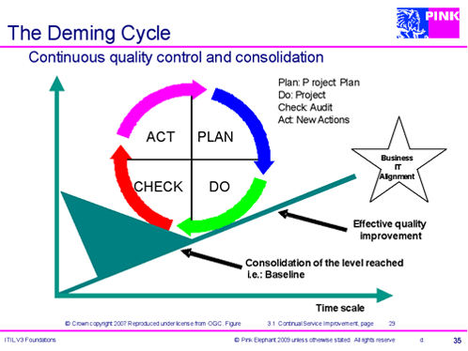

Homework:
Problems 1.1, 1.2, 1.4

Resources:
Quantitative vs. Qualitative Data
http://www.youtube.com/watch?v=EcKrT_IegoU

